LAB2 REPORT
Numbers and Displays
Zhang Zhen
12.14

1. Problem Description
This exercise is about designing combinational circuits that can perform binary-to-decimal number conversion and binary-coded-decimal (BCD) addition.
In Part 2, we are supposed to design a circuit that converts a four-bit binary number V = v3v2v1v0 into its two-digit decimal equivalent D = d1d0. This circuit includes a comparator that checks if the value of V is greater than 9 and uses the output of this comparator to control the seven-segment displays.
In Part 5, we need to design a circuit that can add two 2-digit BCD numbers, A1A0 and B1B0, and produce the three-digit BCD sum S2S1S0. We can use two instances of the circuit from Part 4 to build this two-digit BCD adder. For this part of the exercise, we should use simple assignment statements to specify the required logic functions, and not use other types of VHDL statements such as IF-ELSE or CASE statements.
Another approach for describing the two-digit BCD adder in VHDL code is to specify an algorithm. In Part 6, we are required to implement the two-bit BCD adder with the algorithm being specified. The purpose of this part of the exercise is to examine the effects of relying more on the VHDL compiler to design the circuit by using IF-ELSE statements along with the VHDL > and + operators.
Finally, in Part 7, we need to design a combinational circuit that can convert a 6-bit binary number into a 2-digit decimal number represented in the BCD form.

2. Design Formulation
Part 2:
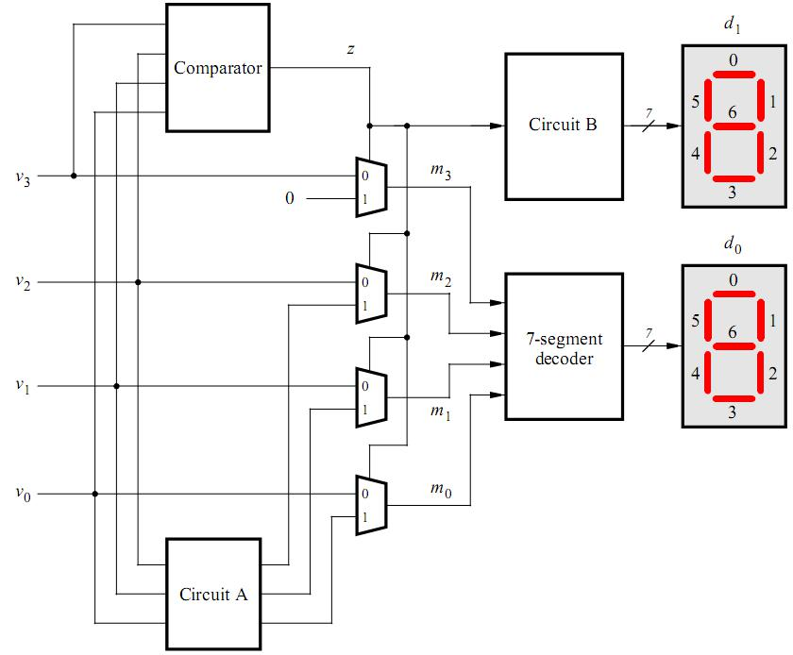
Figure 1. Partial design of the binary-to-decimal conversion circuit.
Consider the circuit in Figure 1. This circuit includes a comparator that checks if the value of V is greater than 9 and uses the output of this comparator to control the seven-segment displays.
We can notice that when z = '1', the output of the topmost multiplexer is always '0'. Since z = '1', i.e., there is a rounding, it is necessary to consider how to convert the lower three bits of the binary number to a BCD code in this case. Since the highest bit of a four-bit binary number corresponds to 8, to convert it to 10, you need to take away 2 from the lower three bits, so subtract 2 from the lower three bits to get the corresponding BCD code. When z = '0', the output corresponding to the multiplexer is the input itself.
m <= ‘0’ & std_logic_vector(unsigned(temp) - 2) when z = ‘1’ else v;

Part 5:
In Part 5, we need to design a circuit that can add two 2-digit BCD numbers, A1A0 and B1B0, and produce the three-digit BCD sum S2S1S0.
Since 6 of the 16 numbers that can be represented by a 4-bit binary number are not used by the BCD code, we add another 6 to the sum whenever the sum is greater than 9 in order to get the correct result.
The hardware structure for summing two BCD numbers is given in Figure 2. We use a binary adder to add the lower 4 digits of two BCD numbers, and if the sum is more than 9, we add another 6 and generate a rounding bit for the next higher 4 digits to be added. The addition of the higher BCD digits is done in the same way.

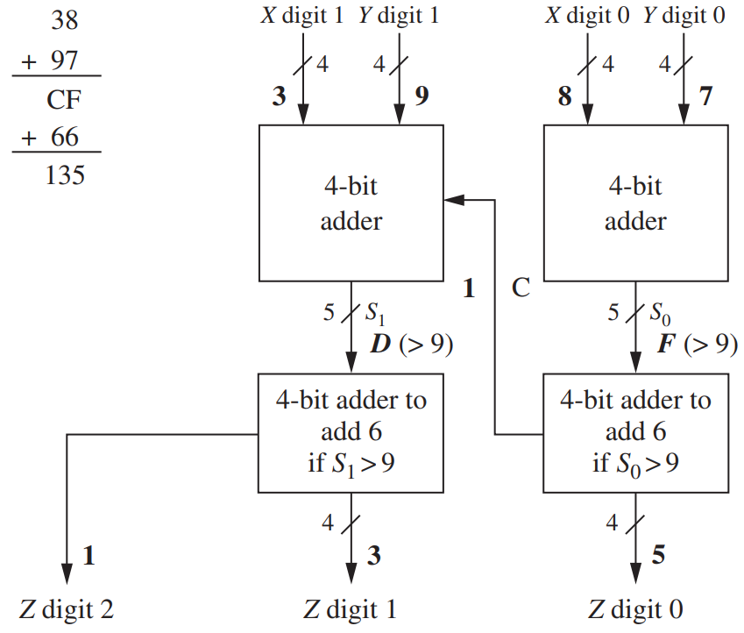
Figure 2. Adding two BCD numbers.

Part 6:
In Part 5, concurrent statements are mainly used to implement two BCD number adders. According to the pseudo-code given in Part 6, if-else statements are used. This requires us to use sequential statements to implement two BCD digital adders where the sensitive signals are T0 and T1. The hardware circuit can be implemented using adder, multiplexer and comparator as well.

Part 7:
In Part 7, we need to design a combinational circuit that can convert a 6-bit binary number into a 2-digit decimal number represented in the BCD form.
We can convert this 6-digit binary number first to the corresponding decimal integer, which ranges from 0 to 63. Then, we can obtain its tens digit and digits by dividing by 10 and taking the remainder of 10, respectively. Finally, the obtained ten digits and digits are converted to the corresponding BCD code.
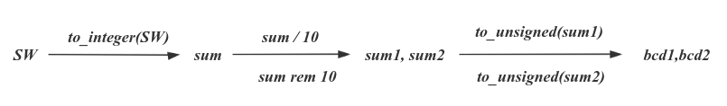

3. Design Entry
Part 2:
part2.vhd :
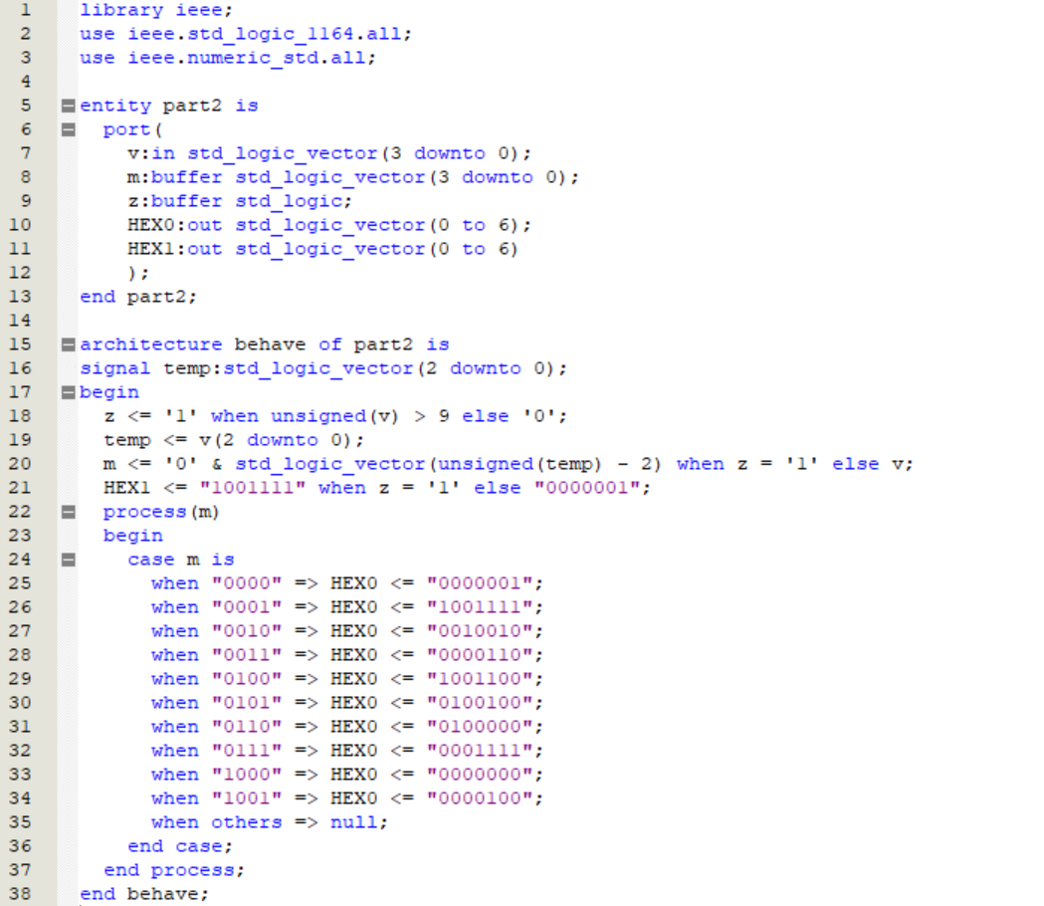

Part 5:
part5.vhd (top-level entity):
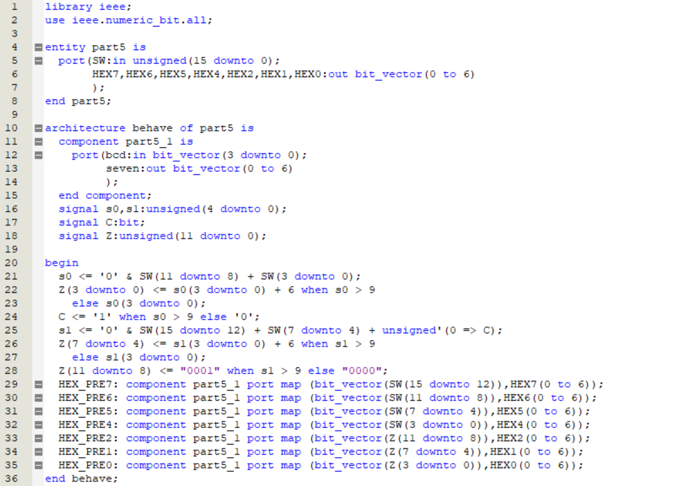
part5_1.vhd (component):
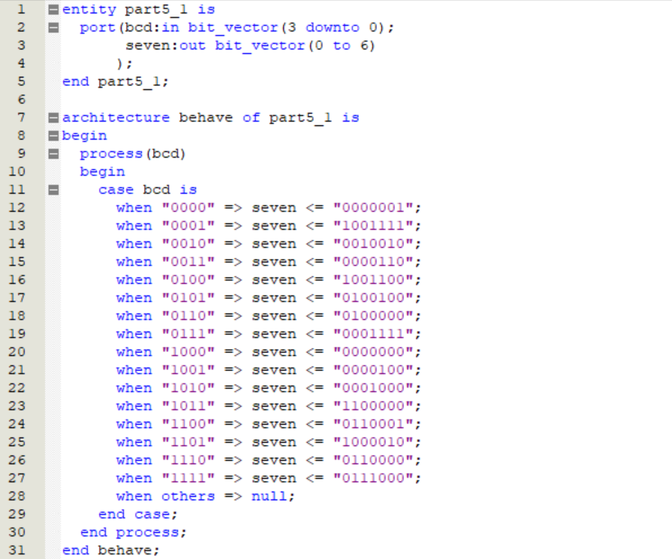
Part 6:
part6.vhd (top-level entity):
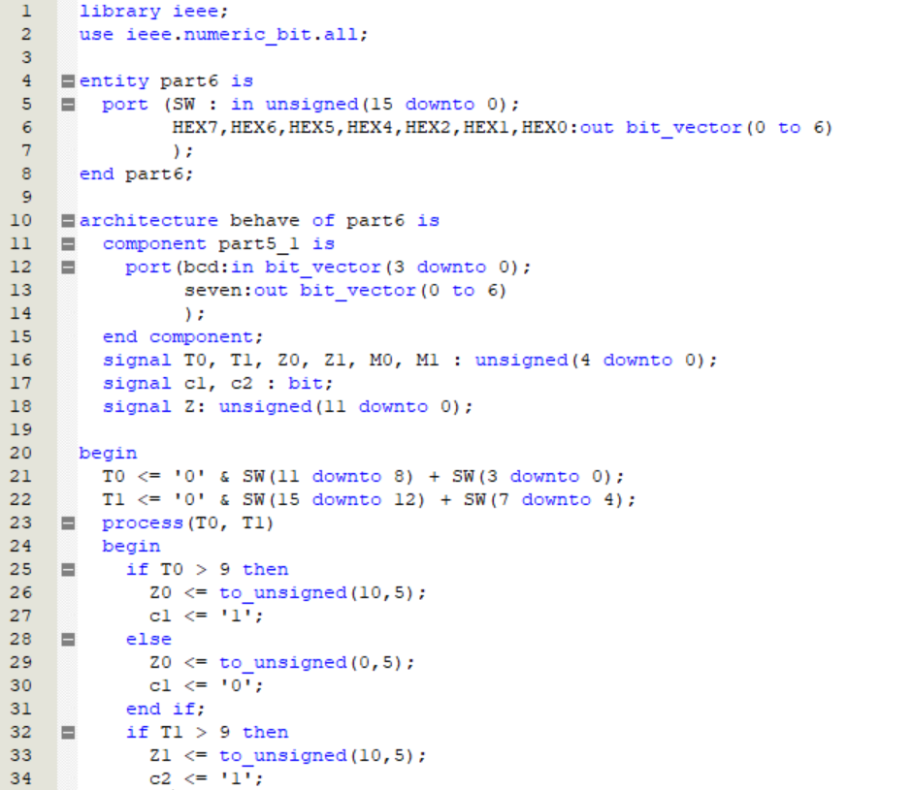
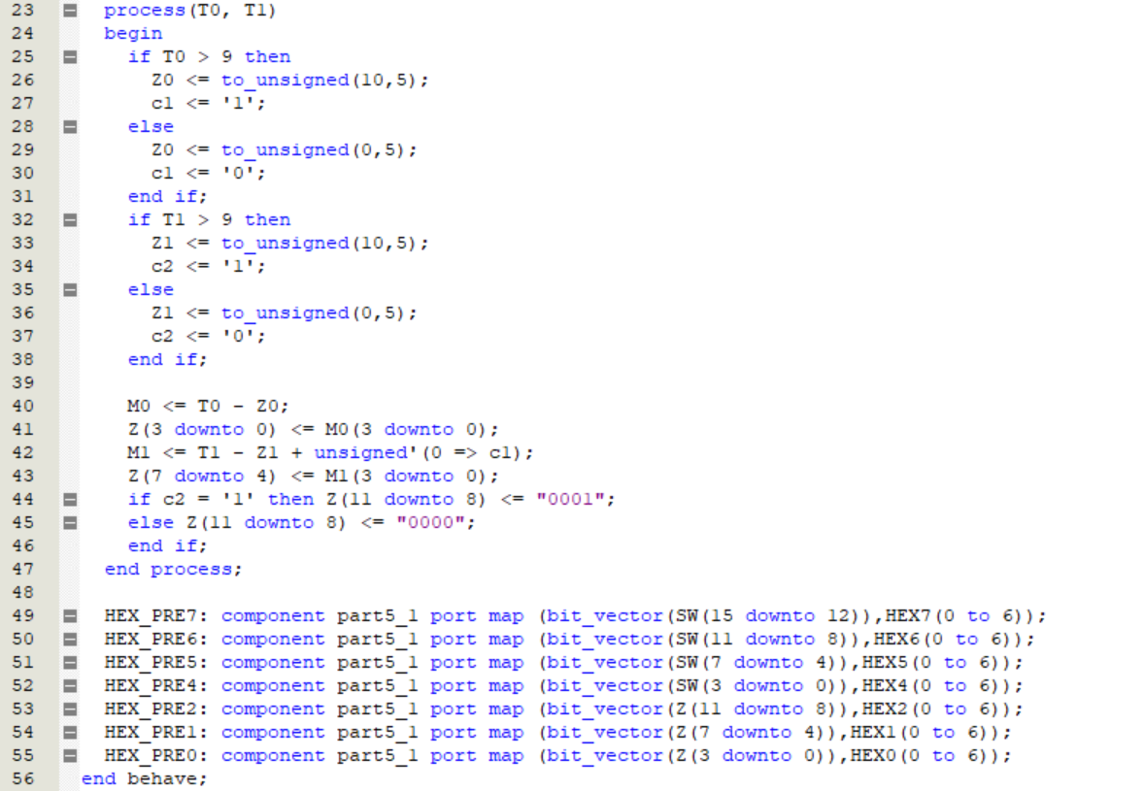
Part 7:
part7.vhd (top-level entity):
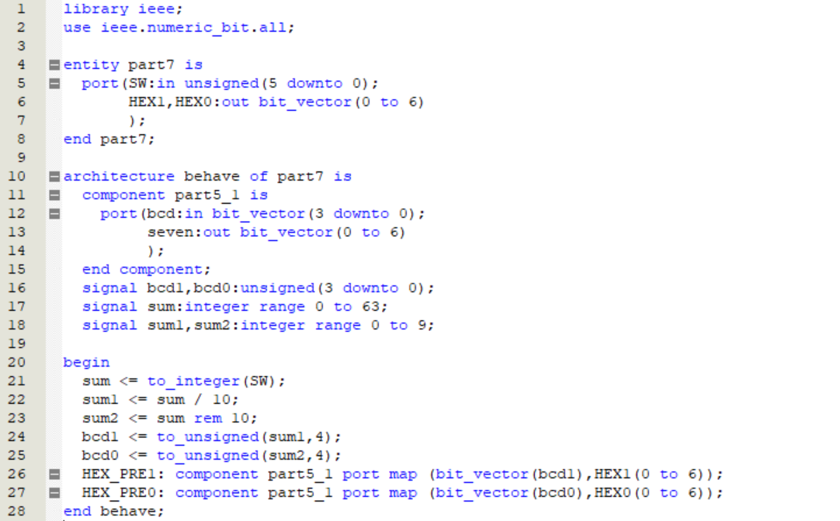

4. Simulation and Synthesis Results
Part 2:
When v goes from "0000" to "1111", the values of z and m are correct and the corresponding digital tube display is correct.
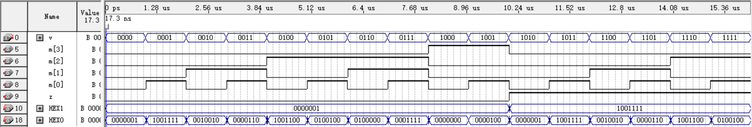

Part 5:
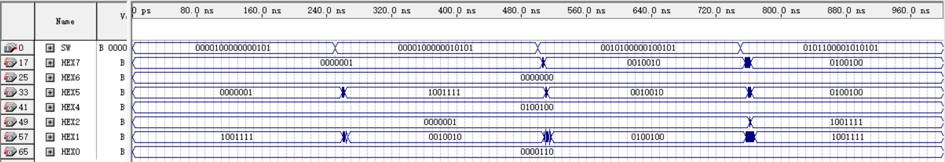
A1A0 | 00001000 (08) | 00001000 (08) | 00101000 (28) | 01011000 (58)
B1B0 | 00000101 (05) | 00010101 (15) | 00100101 (25) | 01010101 (55)
HEX2 HEX1  HEX0 | 0000001 1001111  0000110 (013) | 0000001 0010010  0000110 (023) | 0000001 0100100  0000110 (053) | 1001111 1001111  0000110 (113)
Adding two two-digit BCD numbers A1A0 and B1B0 successfully results in a three-digit BCD S2S1S0.
Use the Quartus II RTL Viewer to see how Quartus II software synthesizes the circuit:

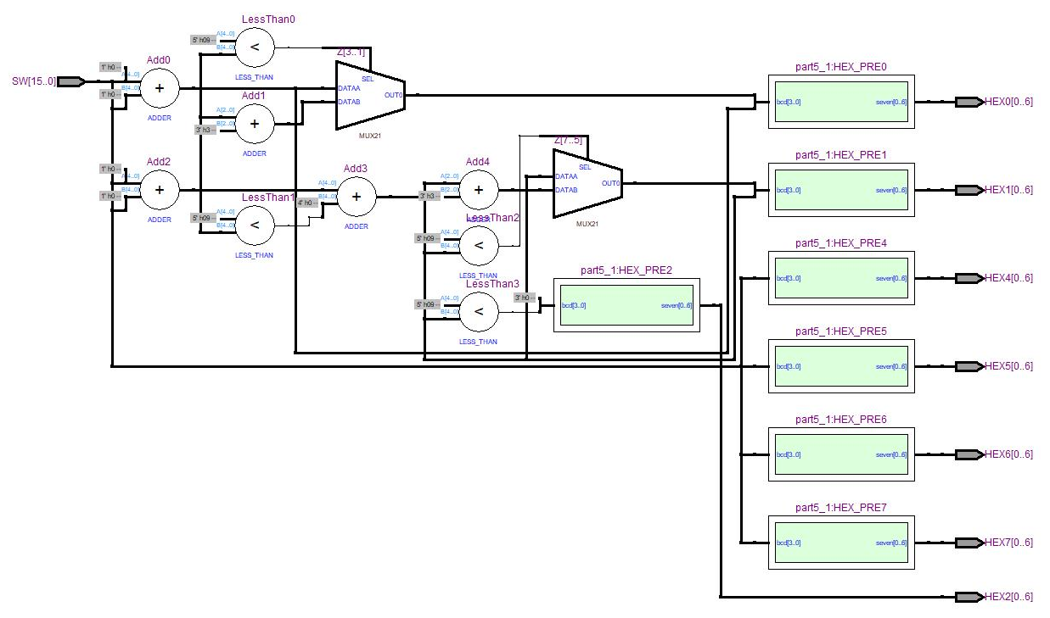

Part 6:
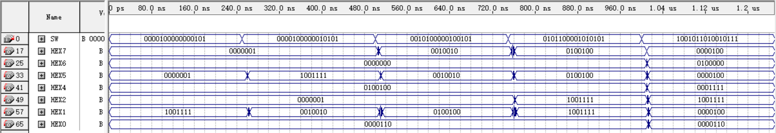
A1A0 | 00001000 (08) | 00001000 (08) | 00101000 (28) | 01011000 (58) | 10010110 (96)
B1B0 | 00000101 (05) | 00010101 (15) | 00100101 (25) | 01010101 (55) | 10010111 (97)
HEX2  HEX1  HEX0 | 0000001  1001111  0000110  (013) | 0000001  0010010  0000110  (023) | 0000001  0100100  0000110  (053) | 1001111  1001111  0000110  (113) | 1001111  0000100  0000110  (193)
Adding two two-digit BCD numbers A1A0 and B1B0 successfully results in a three-digit BCD S2S1S0.
Use the Quartus II RTL Viewer to see how Quartus II software synthesizes the circuit:
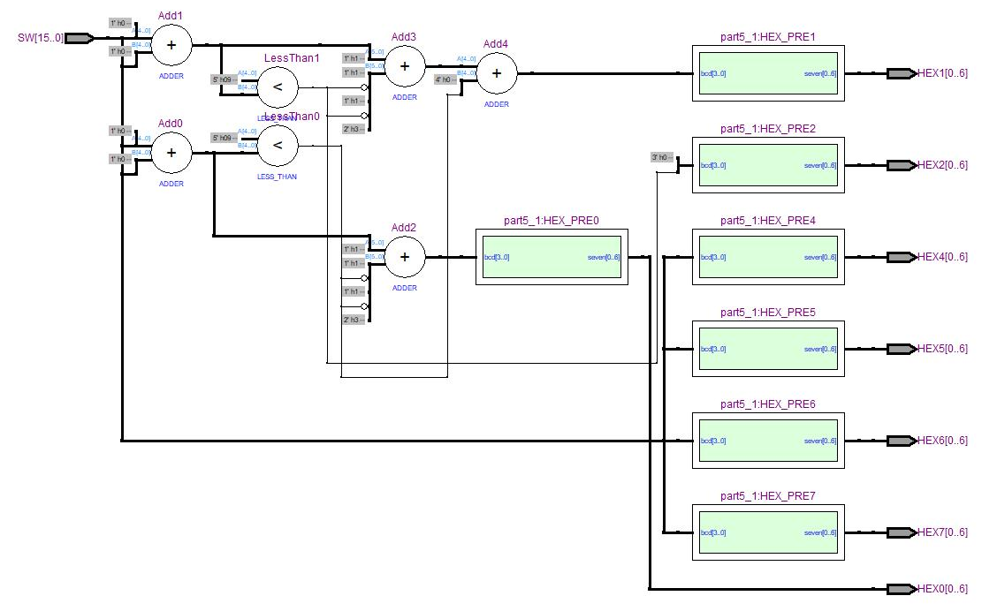
Upon examining the circuits synthesized from Part 5 and Part 6, it is evident that the latter requires fewer components. Although both circuits use five adders, Part 6 utilizes two fewer "less than" than Part 5. To top it off, Part 6 doesn't employ a multiplexer at all.

Part 7:
When the 6-bit binary number is "000000", the corresponding digital tube displays "00"; when it is "000111", it displays "07"; when it is "111000", it displays "56"; when it is "111111", it displays "63". As a result, the 6-bit binary number is successfully converted to a 2-digit decimal number in BCD form.

5. Experimental Results
Part 5:
Experimental Results | Analysis
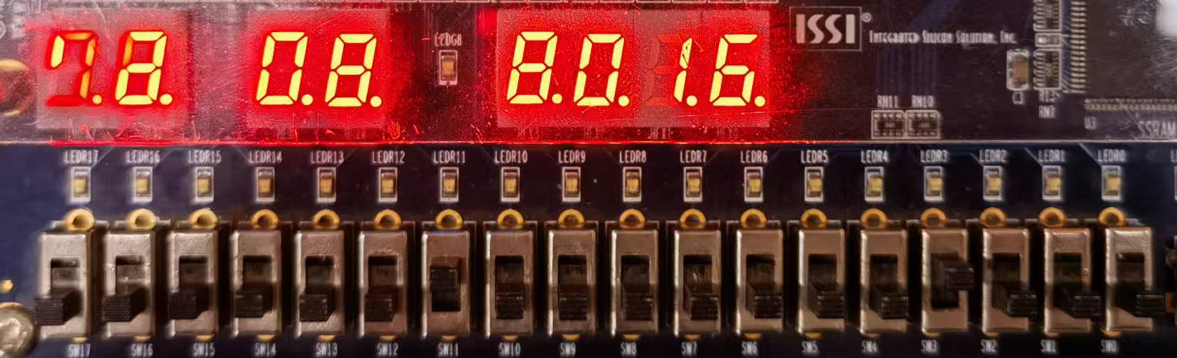 | Adding two two-digit BCD numbers A1A0 and B1B0 successfully results in a  three-digit BCD S2S1S0.  When A1A0 is "08",  B1B0 is "08" , the result is "016";  When A1A0 is "08",  B1B0 is "15" , the result is "023";  When A1A0 is "98",  B1B0 is "98" , the result is "196".
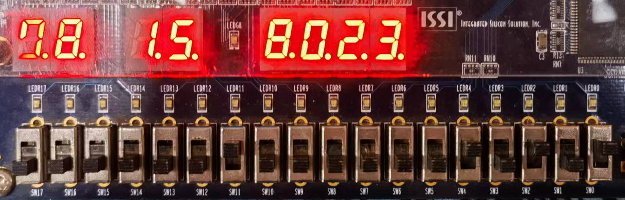
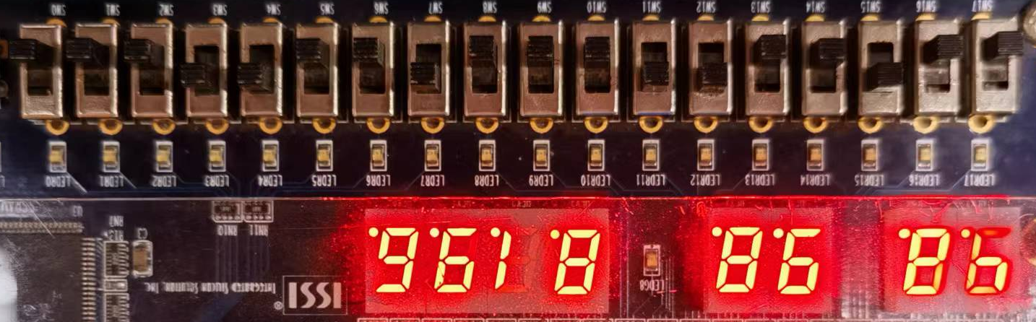

Part 7:
Experimental Results | Analysis
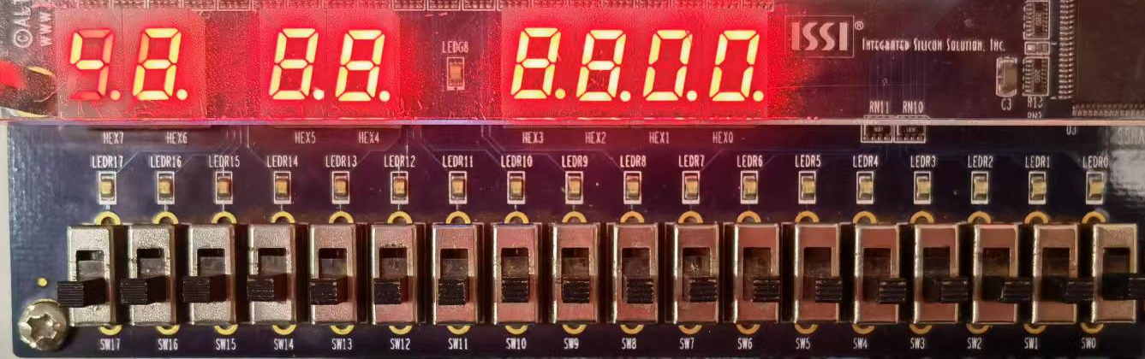 | The 6-bit binary number is  successfully converted to a  2-digit decimal number in  BCD form.  When the 6-bit binary  number is "000000", the  corresponding digital tube displays "00";  When the 6-bit binary  number is "000111", the  corresponding digital tube displays "07";  When the 6-bit binary  number is "111000", the  corresponding digital tube displays "56";  When the 6-bit binary  number is "111111", the  corresponding digital tube  displays "63".
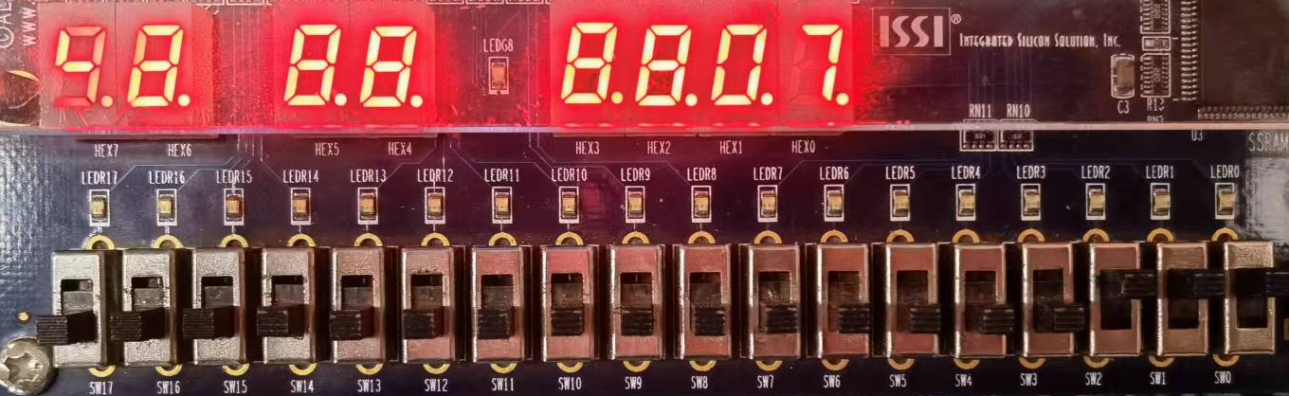
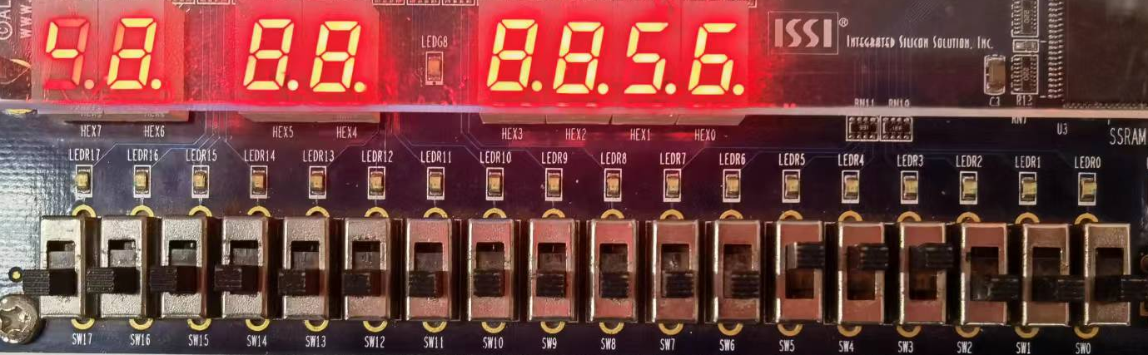
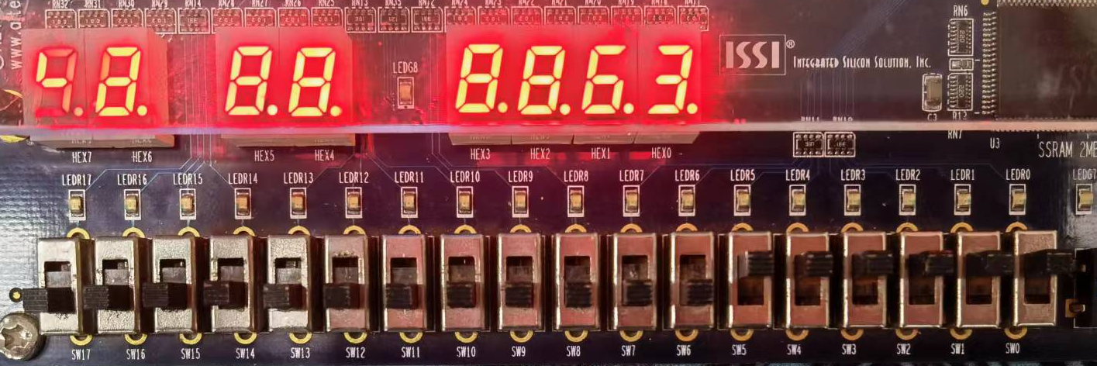

6. Discussion and Conclusion
Problem I:
Most of the problems I encountered in this experiment were related to common conversion functions: different data should be converted using specific conversion functions. numeric_bit package collection contains common conversion functions:
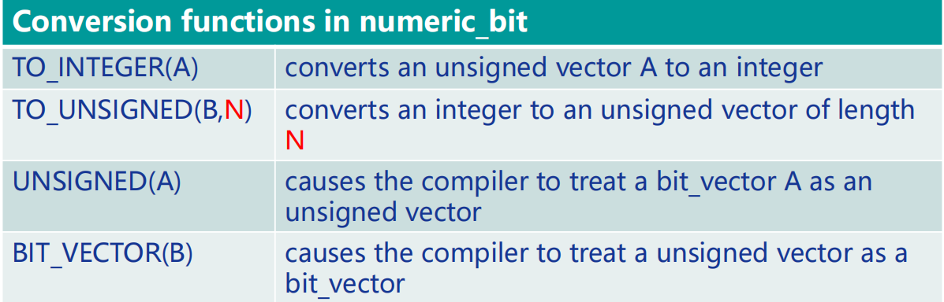
If multivalued logic is needed, use IEEE standard numeric_std package set instead of numeric_bit. The numeric_std package set defines unsigned and signed types as std_logic vectors instead of bit_vector.
Conclusion:
During the course of this experiment, I was able to gain a deeper understanding of binary-to-decimal conversion and BCD addition operations. I became proficient in converting binary numbers to decimal form in BCD and displaying them through a seven-segment digital tube. Additionally, I learned how to write a two-digit BCD adder using both concurrent and sequential statements. Most importantly, I gained new knowledge of the numeric_bit and numeric_std package collections and was able to comprehend the scope of their use.

